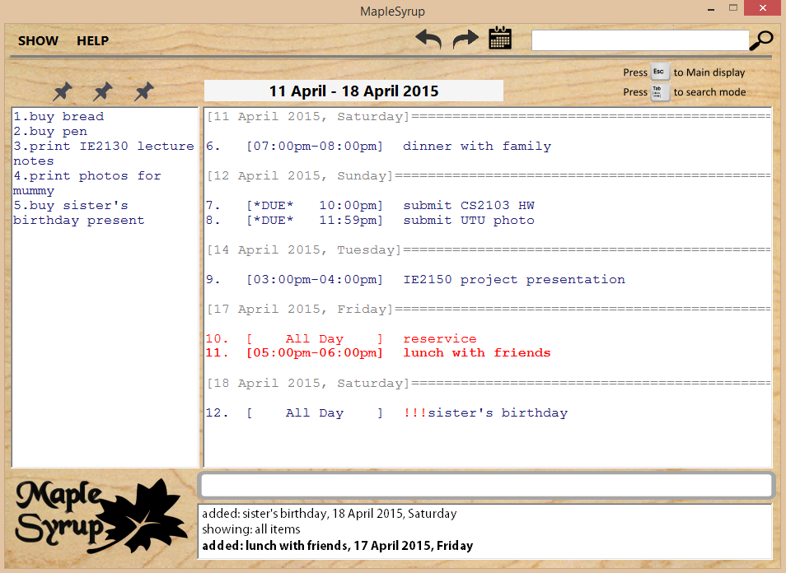

Supervisor: Lim Yu De Extra feature: GoodGUI

|  |  |  |  |
| --- | --- | --- | --- |
| wj  Ong Wei Jee  Team Lead Code Quality | George Passport Pic1  George Lam Changwei  Github Expert Documentation | Ter Yong Kang  GUI Designer Deliverables and Deadlines | che  Che Jian Yong Joshua  Integration Scheduling and tracking |



User Manual

Introduction

Welcome to MapleSyrup, your go to application to keep track of tasks and events! An event in MapleSyrup consists of several details: the name, date, time, and importance. This guide will walk you through the process of adding, deleting, editing, displaying events, and undoing and redoing your commands (because everybody makes mistakes).

Getting Started

Double click MapleSyrup on your desktop.

The main display will show all your tasks and events for today. On-going tasks will be displayed on the left panel.

Command Mode

By default, Maplesyrup will be in the command mode. You will be able to see your cursor in the command box where you will be typing your commands. All the features in MapleSyrup are accessible from this mode. Here, you can add, delete, edit and show events. The tooltip guide below the command box will guide you in entering your commands. All keywords that you type will be highlighted in a different colour.

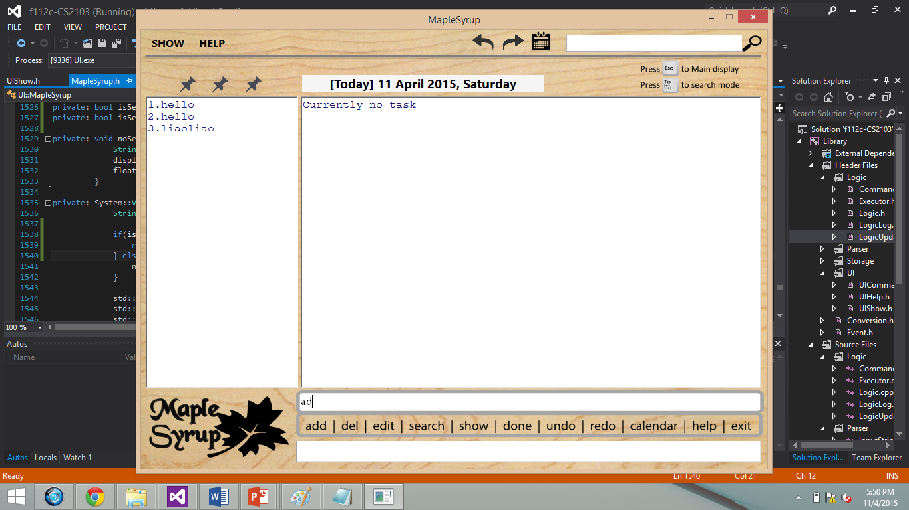

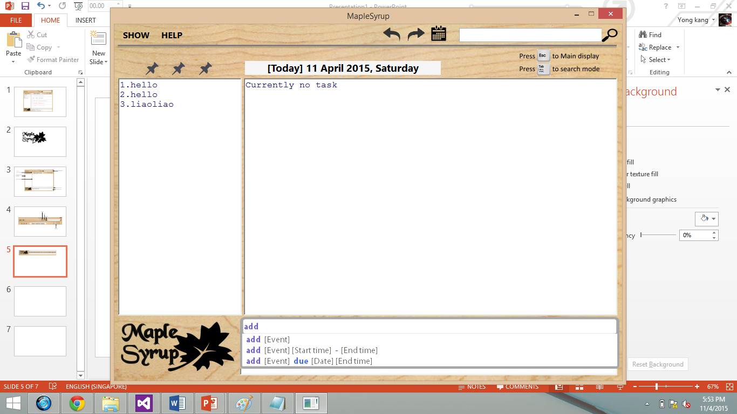

Navigate: To plan and direct the course of a ship, aircraft, or other form of transport, especially by using instruments... Wait, wrong one.

Navigate In Command Mode: Press TAB to enter the Search Mode. Press ESC to enter the Display Mode.

Search Mode

In search mode, your cursor will be in the search box at the top right of the window. You will be able to view your search results while typing in the search box.

Navigate: Press TAB to enter the Command Mode. Press ESC to toggle between the ongoing-events display and the main display.

Display Mode

In display mode, no commands can be entered ☹. Pressing the left and right arrow keys will change the displayed range of dates. Pressing the up and down arrow keys will scroll through the displays ☺.

Navigate: Press TAB to enter the Command Mode. Press ESC to cycle between the ongoing events list to the normal events list.

Maple Tips

* NOT IMPORTANT: Maple syrup is usually made from the xylem sap of maple trees.
* IMPORTANT: Type "commands" or "shortcuts" to access... well what do YOU think they access?
* BREAKING NEWS: Press CTRL-D to call the calendar. Thereafter, use SHIFT + arrow keys to select the dates of your choice followed by ENTER to display events in your selected dates.

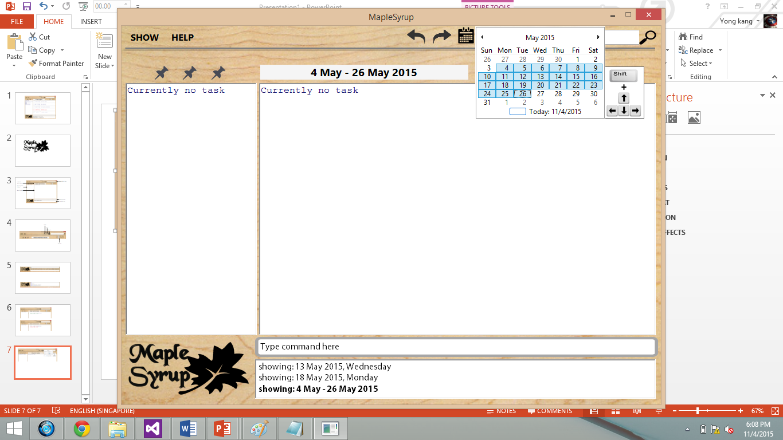

Functions

ADDING AN EVENT

Description:

Events (or tasks) can be added with the command **add**. An event must have a name, and can be assigned dates, from a starting date to an ending date; times, from a starting time to an ending time; and importance levels as indicated by ‘!’. Events can also be given a deadline.

General Format:

“add [event name] [importance] [date] [time]”

An event name is compulsory for all events and must be the FIRST word/words after the keyword add. Date, time, and importance are optional and can be omitted.

Types of Adding:

Ongoing Events

To add Ongoing Events, only an event name is needed.

“add drink maplesyrup”

Single Day Events

To add Single Day Event, add at least a date.

“add drink maplesyrup 1 jan”

“add drink maplesyrup 1 jan 3pm"

“add drink maplesyrup 1 jan 3pm - 4pm”

Multiple Day Events

To add Multiple Day Event, add a start date and end date.

“add drink maplesyrup 1 jan - 31 dec” (but don't forget your vegetables)

“add drink maplesyrup 1 jan 1am - 31 dec 11pm”

Deadline Events

Adding Deadline events requires a due or by keyword. Deadline events can only accept 1 date and 1 time input!

“add drink maplesyrup due 5pm”

“add drink maplesyrup by 31 dec 11pm”

Important Events

Events can also be assigned an importance level. There are 3 levels of importance (!, !!, !!!). Simply enter ! after your event name.

“add drink maplesyrup ! 1 jan”

“add drink maplesyrup by 31 jan 2pm !!!”

Recognisable forms of inputs:

Identifier:

* -  / to

Date:

* 14apr / 14april / 14 apr
* today / tdy / tomorrow / tmr / mon / tues / wed / thurs / fri / sat / sun
* next mon / next tues /…
* jan / feb / ...

Time:

* 1am / 1 am / 1.30 am / 1.30am
* 1-3pm / 1pm-3pm / 1 pm to 3 pm

Display:

Newly added events are displayed in bold **green** and all other events displayed in blue.

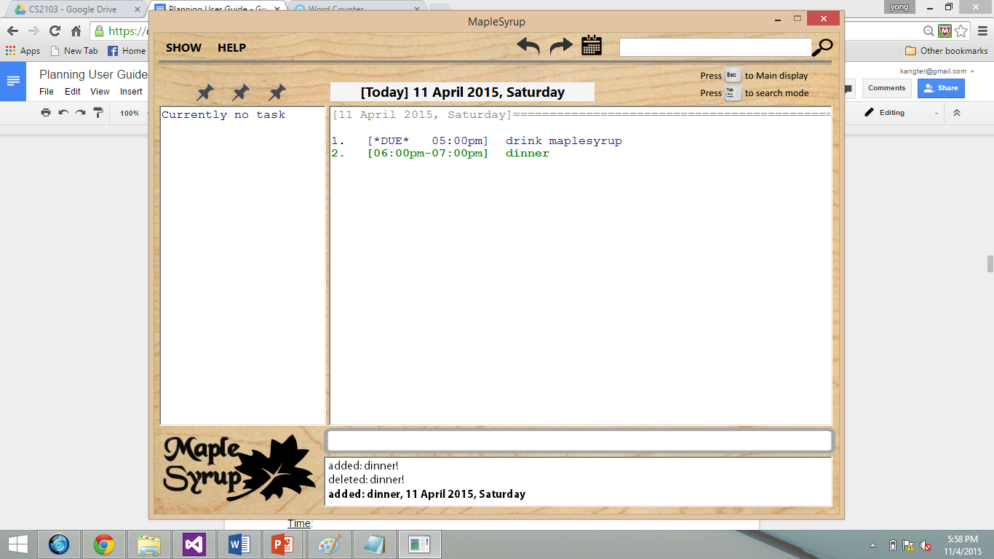

In the case of a clash in timings between the new event and existing events, all clashing events will be highlighted in red to alert you, with the new event in **bold**.

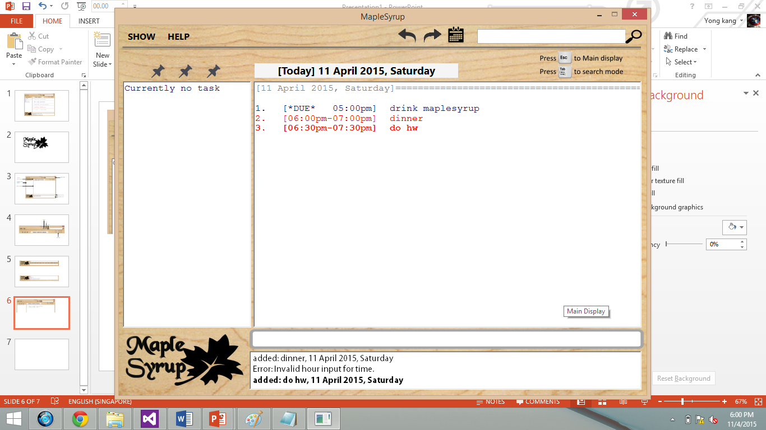

Maple Tips:

* NOT IMPORTANT: Maple syrup is graded according to its density and translucency. Yummy!
* SOMEWHAT IMPORTANT: You can add events without even typing the keyword add.
* IMPORTANT: If you’d like a clearer way to differentiate the event name from the date, type ‘;’ after the event name.
  + “drink maplesyrup**;** by tmr 2pm”

DELETING AN EVENT

Description:

Events can be deleted by typing the keyword **delete** or **del** followed by the event name or its index, which is displayed on the left of the event name.

General Format:

“del [event name/index]”

You can delete an event by name even if the event is not displayed. However, you can only delete an event by index if the index is displayed. Don’t be difficult.

Types of Deleting:

By Name

If there is exactly one result found, that event will be deleted immediately. If there are partial matches or many results with the same name, they will all be displayed and you can take your pick. However, if the name you type is not found, nothing will happen.  Comprehensive, right?

“del drink maplesyrup”

By Index

If the index is found in the display, that event will be deleted immediately. Multiple day events may be represented by more than one index even though they refer to the same event. In this case, deleting any of the corresponding indices will work.

“del 1”

Display:

Deleted events will be removed from the main display immediately and disappear from existence forever until the end of time. Unless you use undo. Then it will come back (amazing). The display will show all the dates where the deleted event used to be.

COMPLETING AN EVENT

Description:

Events can be completed by typing the keyword **complete** or **done** followed by the event name or its index. All other procedures are similar to delete (see above). After any subsequent commands are executed this completed event will be sent to the completed event storage, which can only be accessed by typing “show done” (more on this later).

General Format:

“done [event name/index]”

“completed [event name/index]”

Display:

When you complete an event, it will be struck out in the display, just like how you would cross out your task on your notebook. Except that you don’t have a notebook because it is the 21st century.

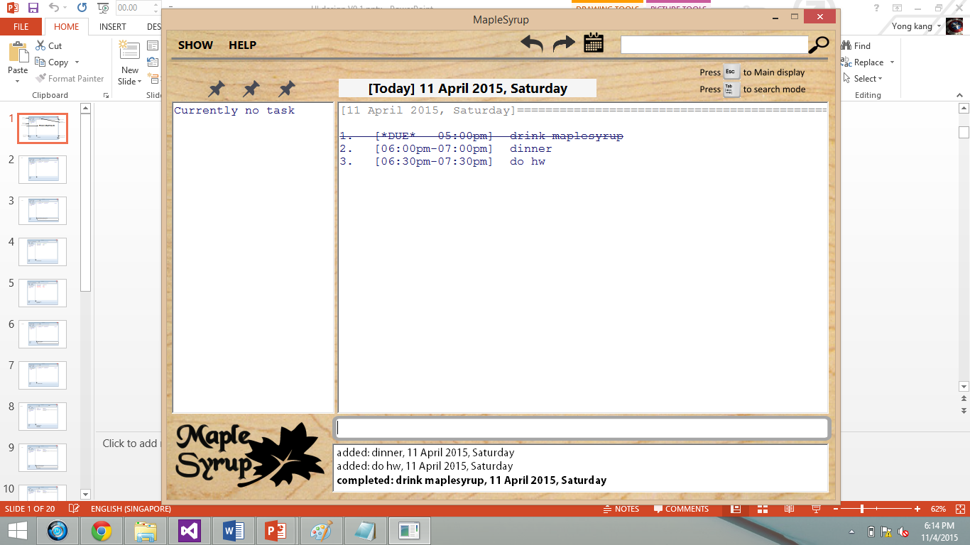

Maple Tips:

* IMPORTANT IN CANADA: In Canada, maple syrup must have a density of 66° on the Brix scale. We do not know what this means.
* IMPORTANT: Once an event is completed, you can only view it using the show done command (think Recycle Bin).
* IMPORTANT: Completed events can ONLY be uncompleted (see next section). Deleting and editing them will not work.
* IMPORTANT: The object oriented way to get wealthy is inheritance.

UNCOMPLETING AN EVENT

Description:

Events can be uncompleted by typing the keyword **uncomplete** or **undone** followed by the event name or its index. All other procedures are similar to the procedures for delete and complete (see above). If successfully uncompleted, the event will be shown normally on the display.

General Format:

“undone [event name/index]”

“uncomplete [event name/index]”

Maple Tips:

* IMPORTANT: **Uncomplete** will only work when the completed event is currently shown on the display.
* IMPORTANT: Remember to check your feedback box after every command.
* VERY IMPORTANT: Maple syrup goes well with pancakes. But have you tried it with waffles?

EDITING AN EVENT

Description:

All details of an event: name, date, time, importance; can be edited by using the command **edit**.

General Format:

“edit [event name/index]; [new event name] [new importance] [new date] [new time]”

The event name or index of the event to be edited is compulsory. After the event name or index, you MUST type ‘**;**’ before adding the new details for the event .You must. These new details should only include those that you wish to be edited. All other details that are omitted will be left untouched.

Types of Editing:

Normal Editing (both normal and ongoing events)

Only type details that you wish to edit.

“edit drink maplesyrup; buy maplesyrup”

“edit drink maplesyrup; buy maplesyrup !!! 5may 7-8pm”

Normal Event to Ongoing Event

To remove the time and date of a normal event (i.e. convert to ongoing event), simply omit all new details.

“edit drink maplesyrup;”

Ongoing Event to Normal Event

Ongoing events can be edited to normal events if new dates or new timings are specified.

“edit drink maplesyrup; 5may 7-8pm

Display:

The edited event will be displayed in green, while all other existing events will be in blue. If this newly edited event clashes with other existing events, all clashing events will be highlighted in red. I mean red. We have mentioned this before. Pay attention.

SHOWING EVENTS

Description:

If you want to find specific types of events (e.g. within a time period, by importance level, completed events etc), you are going to NEED and LOVE the **show** command. When you use a **show** command, the display will be updated to what you specifically specify in the specification of your specified input.

General Format:

“show [dates to show]”

“show [importance]”

“show done”

Types of Show:

Single Day

“show 24apr”

“show tmr”

Multiple Days

“show 22-23apr”

“show week”

Month

“show month”

“show april”

“show apr-may”

Year

“show year”

“show 2015-2016”

Importance

“show !!!”

“show important”

“show impt”

Completed

“show done”

“show complete”

“show completed”

All

“show all”

Tentative

“show me the money”

Using the Mouse:

First get your hands on a mouse. No, not from the pet shop. Click the “show” button at the top left of the window (click the mouse, not the window). A drop down menu will appear with “day”, “week”, “month”, “all” and “done”. Click your desired choice. If you desire to stop using our program, click the cross at the top right hand corner and throw this user guide away. Also, you can click the calendar icon beside the search bar. A small calendar will appear. From there, click on any date or drag across dates to show on the display.

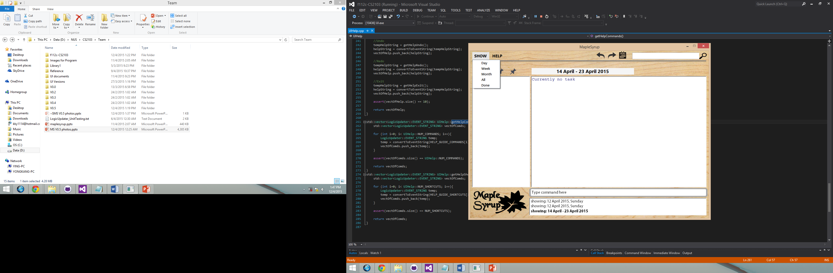

Display:

The main display label will be updated to reflect the dates that you wish to view. If you used a show week/month, the display will be tagged with [week] or [month] and it will stick (like maple syrup) to the week/month mode until you exit it.

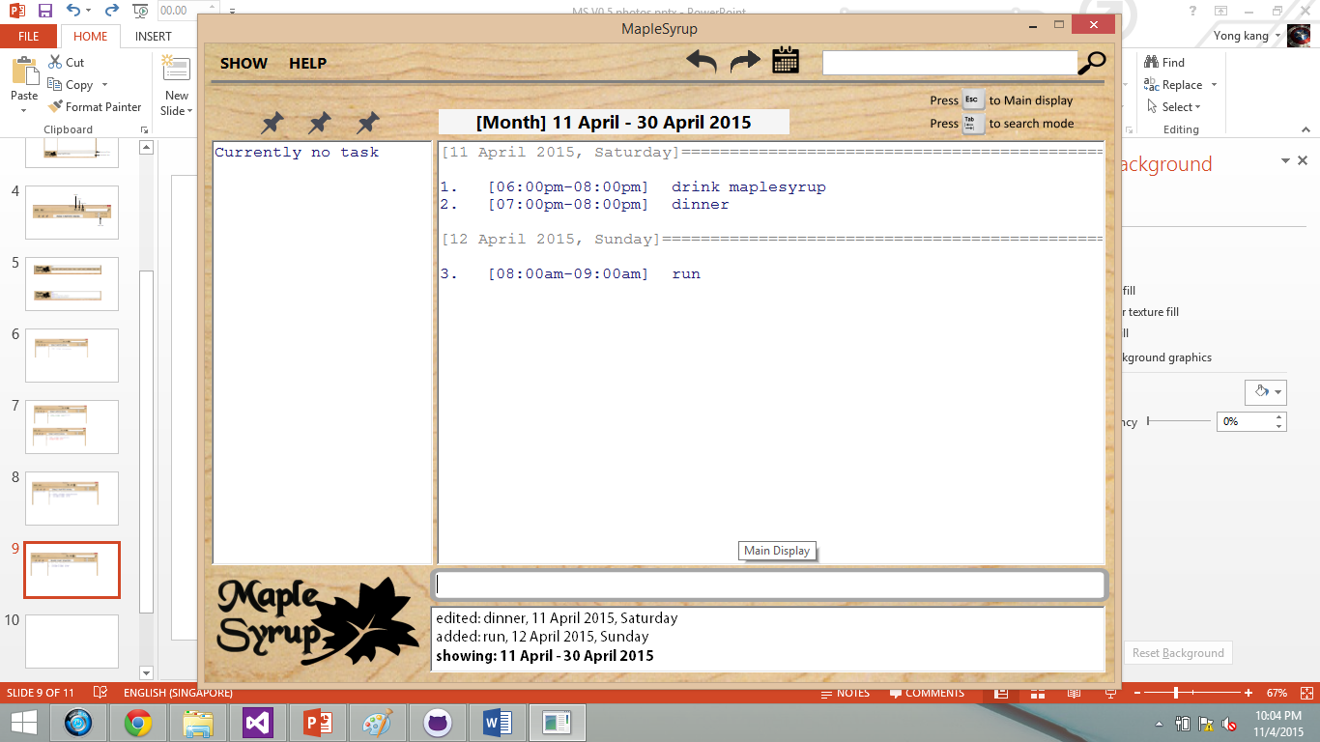

SEARCHING FOR EVENTS

Description:

The **search** bar is located at the top right of the window and it can be accessed by pressing TAB when you are in the command box (or just click in the search bar, you rebel). The **search** results will update every time a new character is typed into the search bar.

Press TAB to go back to the command line after you are done searching. We hope you find what you are looking for.

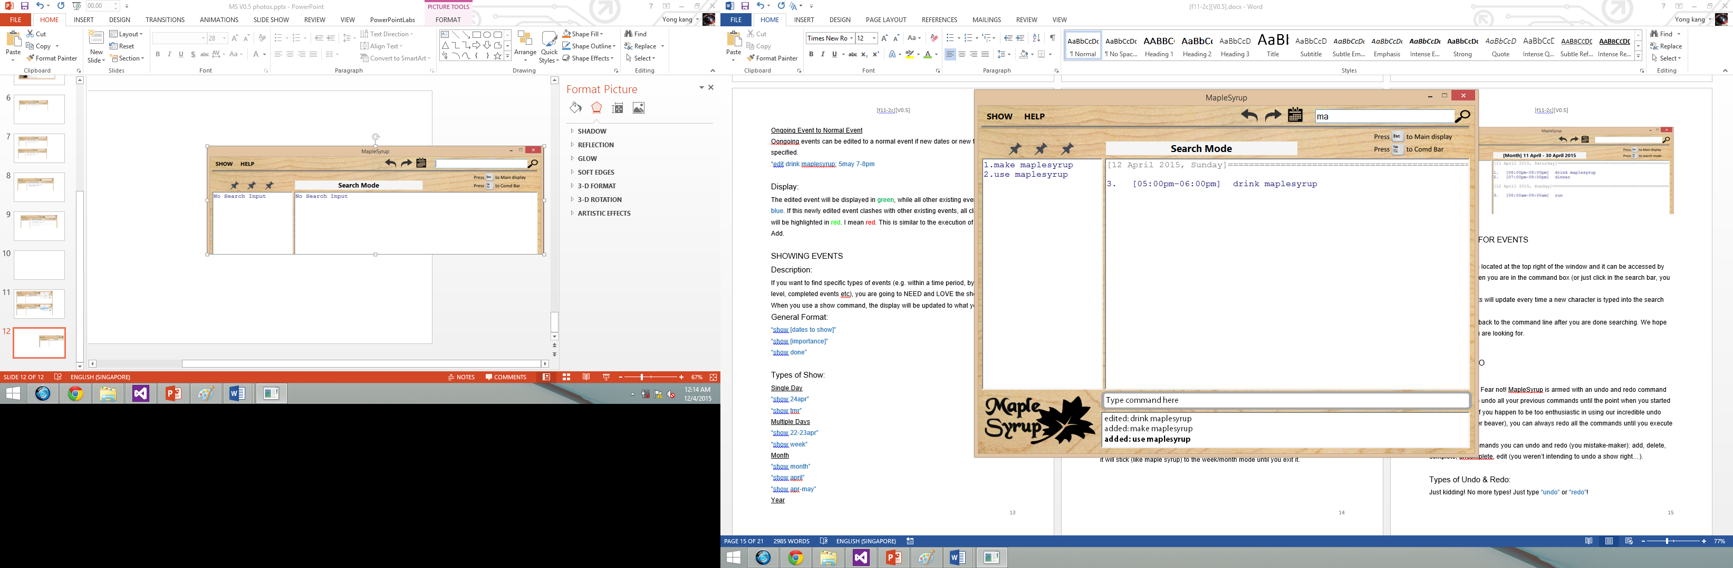

UNDO & REDO

Description:

Made a mistake? Fear not. MapleSyrup is armed with an **undo** and **redo** command that allows you to **undo** all your previous commands until the point when you started up the program. If you happen to be too enthusiastic in using our incredible **undo** feature (you eager beaver), you can always **redo** all the commands until you execute a new command.

Here are the commands you can **undo** and **redo** (you mistake-maker): **add**, **delete**, **complete**, **uncomplete**, **edit**.

Types of Undo & Redo:

Just kidding! No more types! Just type “undo” or “redo”!

Feeling adventurous? Venture to the top of the window and click the undo or redo buttons (you explorer). They really work! Don’t ask us how!

Maple Tips:

* IMPORTANT: Do you know the commonly used keyboard shortcuts for undo and redo? Good for you! Unfortunately only half of them work in MapleSyrup! No but seriously, CTRL-Z works, use CTRL-X to redo.
* IMPORTANT: MAPLESYRUPMAPLESYRUPMAPLESYRUPMAPLESYRUP

HELP

Description:

For lost souls.

General Format:

“help”

Maple Tips:

* Stop reading this already.

Appendix A: User stories.  As a user, …

[Likely]

|  |  |  |
| --- | --- | --- |
| ID | I can … (i.e. Functionality) | so that I … (i.e. Value) |
| addFloating | add a task by specifying a task description only | can record tasks that I want to do some day |
| addLocation | Add location to an event | Will know where I need to be for that event |
| setRecurring | Set events to be recurring every day/week/month | Do not have to replicate similar events that occur every day/week/month |
| anyFormat | Enter new task in any format | Do not have to follow strictly to a certain format |
| setCategories | Organize my events/tasks by categories through tagging | Can search for any event/task easily |
| addAllDay | Add all day events | Do not have to specify time period spanning the whole day |
| setImportance | Rank my task by importance | Can sort tasks by importance and perform more important task first |
| viewAll | View all my task/events in an entire calendar | Can see how busy the week/month is going to be |
| setAbbreviations | Type in commands in the form of abbreviations | Save time by reducing amount of typing |
| setKeyboardCtrl | Open/close the software with keyboard commands | Have a quicker and simpler way of opening and closing the software |
| viewFreeSlots | View all free slots available | Better |
| setAutoSave | Save my inputs after every command | No loss of information if software accidentally closes |
| viewCompleted | View all completed tasks | Have a sense of accomplishment |
| reportClashing | Notified if there is any clashing events/tasks | Reschedule events/tasks to not have any clash |
| allowEdit | Edit my task information | Change any information at any time |

[Unlikely]

|  |  |  |
| --- | --- | --- |
| ID | I can … (i.e. Functionality) | so that I … (i.e. Value) |
| addAlarm | Alarm/reminder when event is coming up | Will not miss important tasks |
| autoReschedule | Let the software auto reschedule my task if I fail to complete it during the set time | Do not need to set a new deadline again |
| setBufferTime | Set buffer time between events at different locations | Do not have a situation where I do not have time to travel from one event to the other |
| setAutoStart | Have the software auto start up when I turn on my computer | Can use the software immediately and be reminded of today’s event right away |

Appendix B: Product survey

|  |
| --- |
| Product: Google Calendar  Documented by: Ter Yong Kang  Strengths:  1. Event colour - allow user to classify events based on colour. This enhance the user experience.  2. Same event can be repeated more than 1 time.  3. Find time function - helps user to find a free time for the event to be added  4. Search function - allows user to search for events according to its details (name etc. etc.)  5. Display density allows user to choose the style of displaying calendar - enhances user experience  6. Displays only the important details of the event (Name & Time) on the summary page. Upon clicking the event, the full details of the event are being displayed. This provides a quick overview for the user without information overloading he/she.  7. A "help" section to provide a quick guide to new users on how to use the program  Weaknesses:  1. Unable to help user prioritise which event is most important given they overlaps  2. Unable to prioritise to user what event/activity to be complicated first  3. Does not allow user to add "floating tasks" without entering date and time  4. Unable to categorise events of the same type (e.g. work, family) together (except through colour)  5. Only able to display in Day Week Month 4Day. Should have more display options such as "display event according to priority" or "events of same type" etc. |
| Product: Macbook Calendar  Documented by: George Lam Changwei  Strengths:  1. Able to add new events easily with detailed information such as location, day and time  2. Able to set alarms and reminder for to do events  3. Able to add invitees, notes, URL, attachments  4. Able to add recurring events and set the recurrence to weekly or monthly or yearly.  5. Able to tag an item by color tags to sort by different categories.  6. Able to sync to Iphone  7. Has a small calendar at the side which help to navigate through the different days and months easily.  8. Has a short cut input bar at the top where users can just describe their event in a sentence and it will be added to the day accordingly. So users do not need to find the add and add the event.    Weaknesses:  1. Only on mac platform  2. Can only sync to apple products  3. Unable to recognise shortforms for users that prefers to type fast  4. Show a lot of information at once which might be overwhelming. Especially to a new user. |
| Product: Wunderlist  Documented by: Che Jian Yong Joshua  Strengths:  1. Able to set due date, and has options for recurring events daily, weekly, monthly, yearly, and even custom (every 2 days, or every 5 days)  2. Able to add additional details to the event  3. Able to star events to label as high priority.  4. Able to search for events based on event title as well as additional info typed on the event  5. Has sorting availability by due dates, and priority.  6. Has automatic grouping of events, by today and week.  7. Allows attaching of file to the event, such as emails or documents that contain additional information on the current event can be linked to  8. Has shortcuts available for quick addition, starring, completing, selecting  9. Keeps records of completed tasks for reference in the future if need be  Weaknesses:  1. Does not allow copying and pasting of events. Not able to set multiple due dates that does not follow a standard recurring structure.  2. Does not allow previewing of all the events in the form of a calendar for easier viewing. (Such as seeing how busy a certain week is)  3. Front page of website does not show all the events. Unable to set Today tab as the first tab viewed.  4. Events for the week cannot be sorted, fixed by due dates. |
| Product: Sony Calendar  Documented by: Ong Wei Jee  Strengths:  1. Can view in day/week/month  2. Option to input location and detailed event description  3. Can specific exact time for events  4. Can set repetition for events  Weaknesses:  1. Setting time by scrolling through numbers is not efficient  2. Reminders only occur 10 minutes before the event  3. Must navigate to respective dates to view events, and it is not always obvious in the GUI |